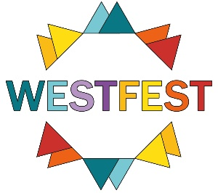

Friday 2nd- Sunday 25th June 2023

EVENT ENTRY FORM
(if you have several events, please fill this in for one and then send basic copy for the others)

NB If you email it in, please also send hard copy with payment

Name of organisation

Address

Contact name(s)

Phone mobile

email

1. Name of Event

- Date(s)

- Time(s)

- Venue name &
Address and
Postcode and
Phone number

5. Ticket price(s)

6. Advance sales (if relevant) from:

7. DESCRIPTION OF EVENT (max 60 words)
NB: We reserve the right to edit the text for length or unsuitable content

8. In what category do you want this event listed?
Please put an “X” in the box beside which one category you choose.
Example: Exhibition | X
(a) Music – folk, jazz, rock and world
(b) Music – classical, recitals
(c) Music: - singing and choral
(d) Theatre and dance
(e) Exhibitions
(f) Talks
(g) Guided walks
(h) Children and families
(i) Film
(j) Comedy
(k) Food and drink
(l) Events

9. Relevant website addresses:
We will link them from our site and please link your sites to WestFest.

www.

10. Social media accounts:

Facebook: @
Instagram: @
Twitter: @

Please note WESTFEST’s social media accounts and tag them where possible, so we can share your content:

Facebook: @WestFestGlasgow
Instagram: @WestFestGlasgow
Twitter: @WestFestGlasgow

TIP: Please also feel free to make WestFest a co-host of your event on Facebook. You can do this by completing the co-host information when you are setting up event on Facebook.

11. Entry Fees
The entry fee is £65 for a ticketed or paying event, plus £45 for each extra event.
The fee is £50 inc VAT for a free or community event, plus £25 for each subsequent event. If you are in doubt what you should pay, please get in touch.
Terms and conditions are available on our website.

12. Payment
- Please pay via bank transfer:
Account Name: West Fest Ltd
Sort Code: 83-07-06
Account number: 19820826
- PLEASE reference your organisation name !!Please make cheques payable to WestFest Ltd’
- Invoices will be sent with proofs in early April.

13. DEADLINE: Please make sure all copy and payment is received by
5pm on Friday 17 March 2023.

Send or hand in to: info@westfest.uk
WestFest, The White House, Dowanhill Park,
Havelock Street, Glasgow G11 5JE
(inside little park with swings opposite Cottier Theatre)

Any queries: info@westfest.uk

Thanks!

Brendon McIlroy
Festival Director

