17th January 2025

Dear Friends,

WESTFEST 2025- Sunday 1st to Sunday 29th June

We are delighted to announce that after a successful festival in 2024, WestFest will be returning this Summer. The second WestFest will be taking place from 1st-29th June.

WestFest 2024 was a success in every measurable way and we’re now planning for a bigger and better WestFest in ‘25.

We’ll be officially launching on 17th January and this is when our new website goes live and when we open for entries.

We really hope you’ll join us again and list your event as part of WestFest 2025. It’s easy to take part and we’ll support you every step of the way.

Please get in touch now if you need a venue or require any advice or support with setting up your event. We will soon be launching our WestFest hub where we will be on hand to offer advice and support on everything from marketing & event planning to insurances and budgeting.

This year we begin on Sunday 1st June. Venues such as Kelvingrove Bandstand, Kelvingrove Galleries and Botanic Gardens will host free outdoor events every weekend, and we are always looking for family and community events at the weekends for our large public to attend! Our opening community event will be the The Big Sunday at Kelvingrove Bandstand (TBC) on Sun 1st June.

In addition to advertising, banners and posters, we will print 40,000 A5 brochures, which will be distributed throughout Greater Glasgow and the central belt. The programme of events will of course be available on the website and our social media platforms.

The Brochure and Website/Social Media are the most effective ways of publicising your event, and to help with our costs will charge a small fee for inclusion.

Unavoidably, there will be a listings price increase from last year to ensure our costs are covered. We will however ensure listing and advertising fees are as low as possible to ensure the festival remains accessible to all.

For ticketed events, a single-entry costs £89 with additional entries £69. For free or community events, a single-entry costs £69, with additional entries £49. For multiple events, we may be able to offer a further discount.

To guarantee your entry in the brochure, please complete the online form at www.westfest.uk/participate

The deadline for copy is 5pm on Friday 28th March

Shortly after your submission we will be in touch to confirm your listing and will send an invoice for payment of fees.

Proofs of your entry will be sent out around 7th April and you will be asked to return your corrected proof within 3 days for us to meet the publication date of the week of 14th April.

Also, please use the WestFest logo on your publicity and indicate that you are part of WestFest on your website and in press statements. Logos can be found on the website.

If you have any queries, please don’t hesitate to get in touch.

Best wishes,

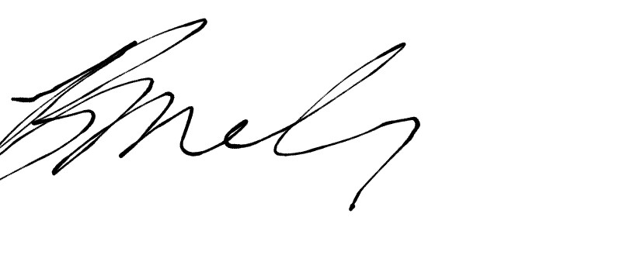
Brendon McIlroy
Festival Director

