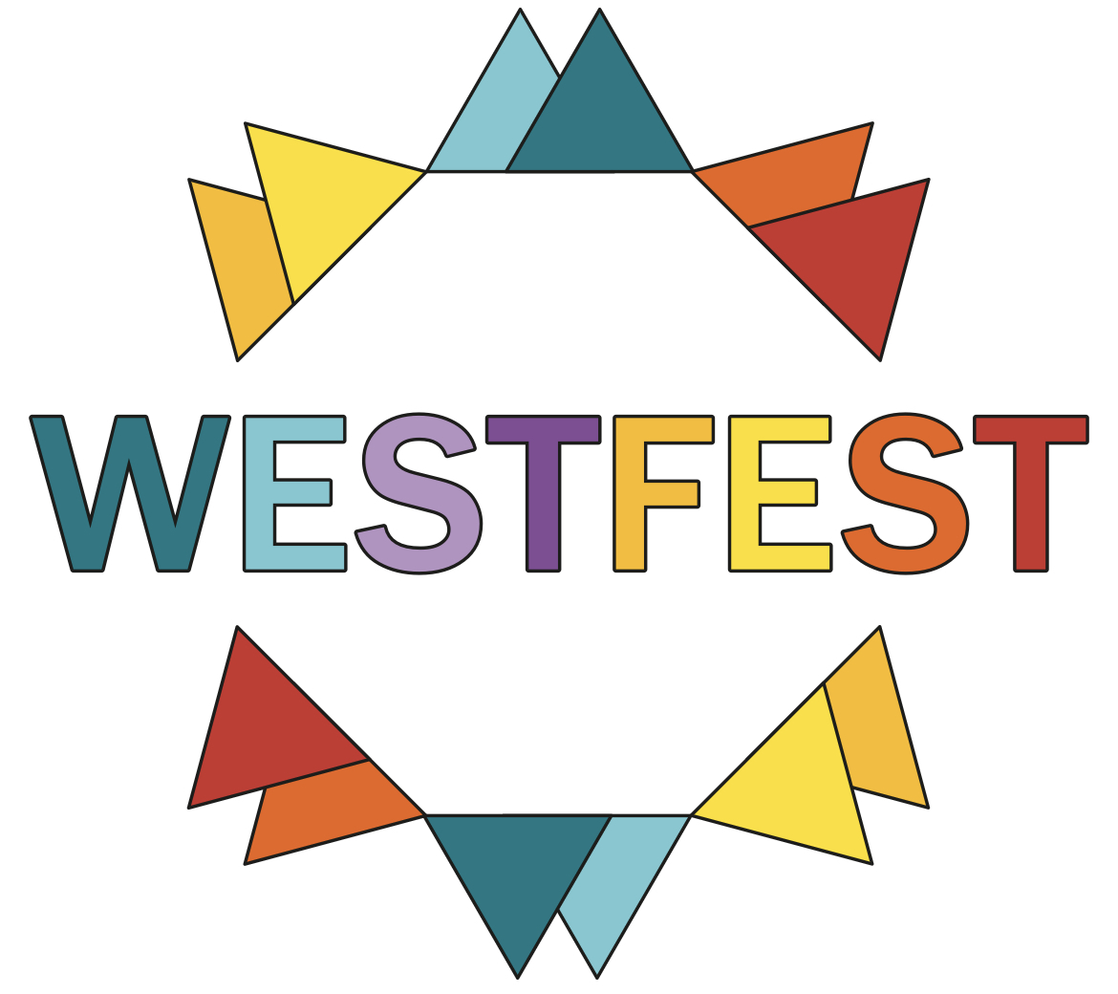

WESTFEST 2025 Advertising Application

Business Name: ………………………………………………………………………..

Contact Name: ………………………………………………………………………….

Address: …………………………………………………………………………………

……………...………………………………………………………………………………

Tel: ………………………………………………………………………………………..

Email: …………………………………………………………………………………….

Signed: …………………………………………………………………………………..

Full back page portrait: 138mm (w) x 200mm (h)  no bleed | supplied as CMYK hi-res jpg or hi-res pdf | £1000
Full page portrait: 138mm (w) x 200mm (h)  no bleed | supplied as CMYK hi-res jpg or hi-res pdf | £ 800
1/2 page landscape: 138mm (w) x 97mm (h), no bleed | supplied as CMYK hi-res jpg or hi-res pdf | £ 450
1/2 page portrait:  65mm (w) x 200mm (h)  no bleed | supplied as CMYK hi-res jpg or hi-res pdf | £ 450
1/4 page portrait  65mm (w) x 97 mm (h)  no bleed | supplied as CMYK hi-res jpg or hi-res pdf | £ 300

To guarantee your advertisement in the brochure, please send this form via email to malcolm@westfest.uk or complete the online form at www.westfest.uk/advertise
We will then be in touch shortly to confirm your advert and will then send an invoice for payment. (If you need an invoice in advance, please let us know asap).
The deadline for artwork and payment is 5pm on Fri 4th April. Publication date is 14th April.

ARTWORK AND PAYMENT DEADLINE:
14th April 2025

