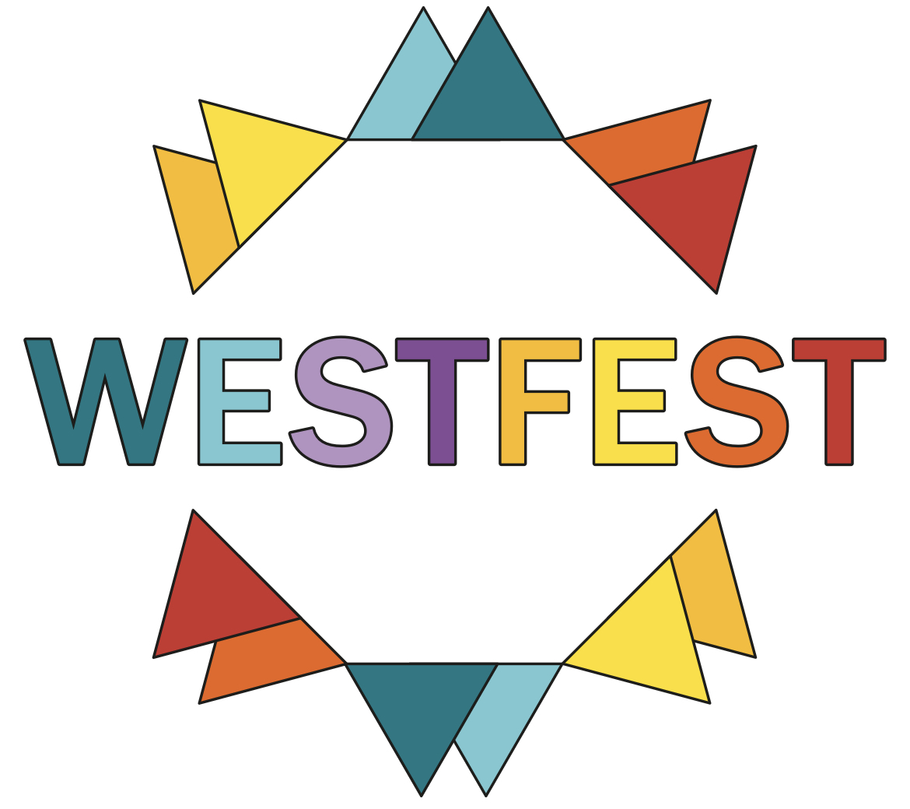

17th January 2025

WESTFEST 2025 – Fri 1st to Sun 30th June

Advertising with WestFest

We are delighted to announce that after a successful festival in 2024, WestFest will be returning this Summer. The third annual WestFest will be taking place from 1st-29th June.

I am writing to send you details for placing an advert in this year’s WestFest brochure and website.

WestFest 2024 was a success in every measurable way and we’re now planning for a bigger and better WestFest in ‘25.

This year we begin on Sunday 1st June. Venues such as Kelvingrove Bandstand, Kelvingrove Galleries and the Botanic Gardens will host free outdoor events every weekend. Our opening community event will be the The Big Sunday at Kelvingrove Bandstand (TBC) on Sun 1st June.

At the heart of the festival will be our programme of free outdoor community events which will take place throughout the month of June, produced by the festival team.

These events will include:
The Big Sunday at Kelvingrove Bandstand
Gibson Street Gala
Mansfield Park Street Festival
Kelvingrove Outdoor Ceilidh
ARC Family Day @ University of Glasgow
Sambayabamba & Friends @ Victoria Park

Total audience figures for our outdoor events is expected to exceed 60,000 this year.

In addition to print advertising, banners and posters, we will print 40,000 A5 WestFest brochures, which will be distributed throughout Greater Glasgow and the central belt. It is estimated that these will be read by around 250,000 people with an interest in the Festival and in Glasgow’s West End.

Distribution will be intense through conventional distribution and through deals we negotiate uniquely with major stores (Waitrose, Sainsburys), SPT, the University and the Council’s own outlets. Total attendance last year was estimated at around 100,000 people, making it one of Glasgow’s largest public events.
The programme will also be available on our website, where we can place your company logo with a direct link to your home page if you take a full page.

This year’s brochure will be in A5 format. The available advert sizes are shown on the form enclosed. A full page is £800; a half page is £450, a quarter page is £300.

To guarantee your advertisement in the brochure, please complete the online form at www.westfest.uk/advertise

We will then be in touch shortly to confirm your advert and will subsequently send an invoice for payment. (If you need an invoice in advance, please let us know asap).
The deadline for artwork and payment is 5pm on Monday 7th April. Publication date is week of 14th April.

By placing an advert, you will help guarantee the future of WestFest, as well as attract attention to your business.

It's important to highlight again that WestFest has no affiliation with West End Festival (Glasgow) Ltd and that this is a separate festival and non-profit organisation.

If you have any questions, please email us on info@westfest.uk or call 0141 342 5997

Best Regards,

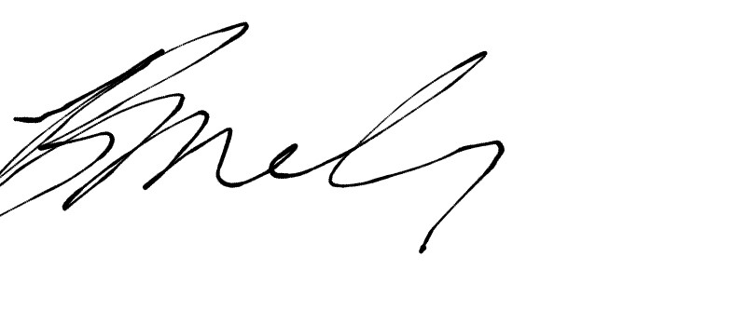
Brendon McIlroy
Festival Director

